This tutorial teaches how to build Linux distributions as screensavers for Microsoft Windows, with your choice of boot screen and wallpaper. The intent of this is to construct items containing corporate logos which can be distributed as marketing novelties.

All required software and data is open source and is accessible on the public Internet.

Hardware requirement: A PC running Windows 10 or newer which is capable of running WSL2. WSL2 only runs on some CPUs and requires a BIOS setting to enable virtualization.

Internet requirement You will download up to 10 GB of data in all cases, and up to 100GB of data if you choose to download all the source code.

The required SVG (scalable vector graphic) files can be edited with Inkscape, an open source item available for Linux, Apple Mac, and Microsoft Windows; or with commercial products such as sold by Adobe.

I set up a screensaver with a Debian logo. Here is a video from the screensaver kicking in to the point where you can play with the open source games  <https://youtu.be/Q_n39c8pUGw>

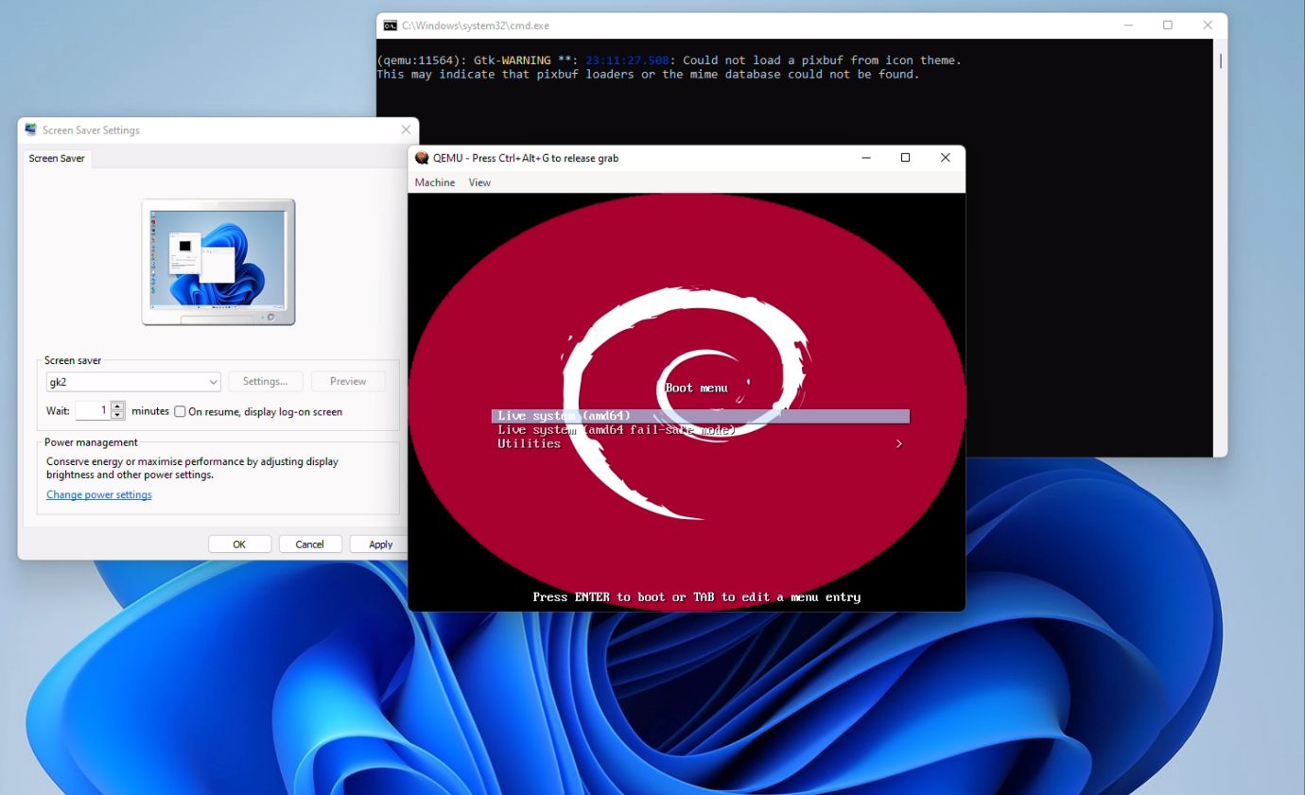

Install WSL2 with Debian

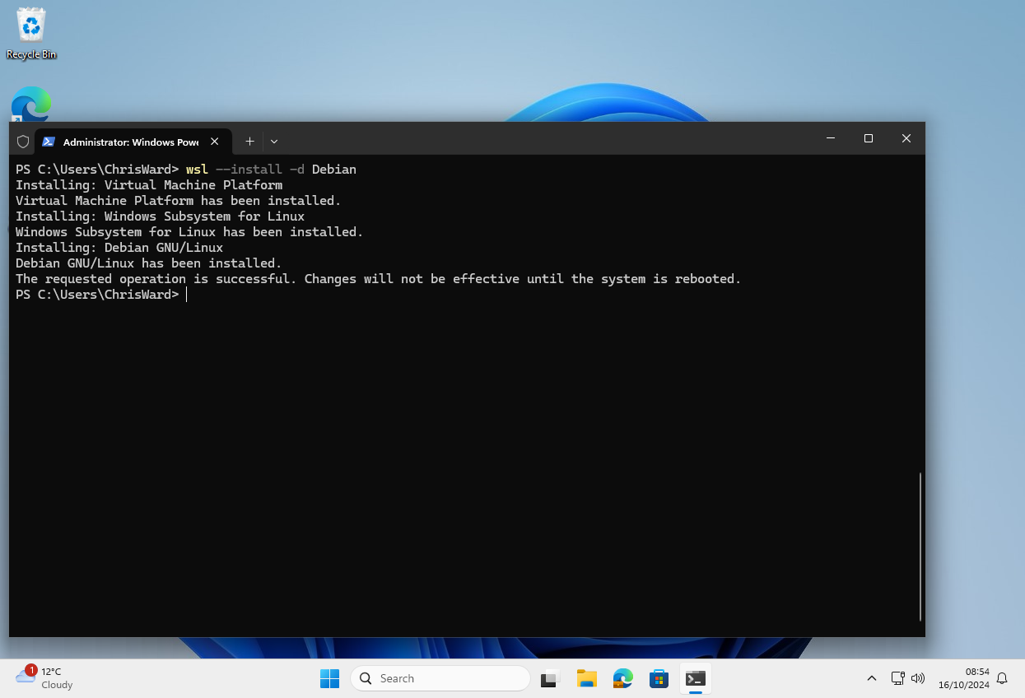

Install cygwin from <https://cygwin.com/> with git

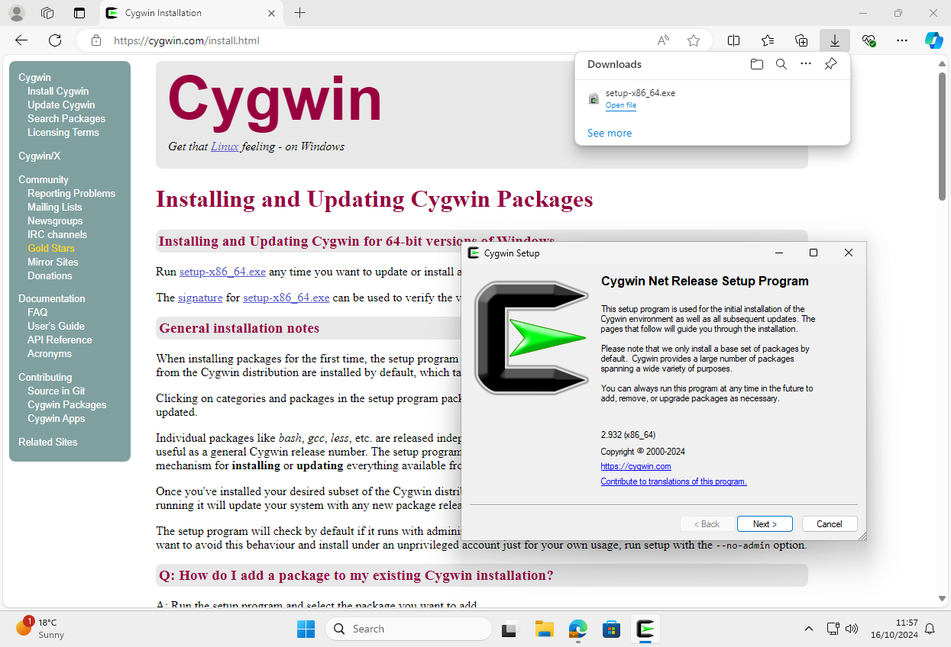

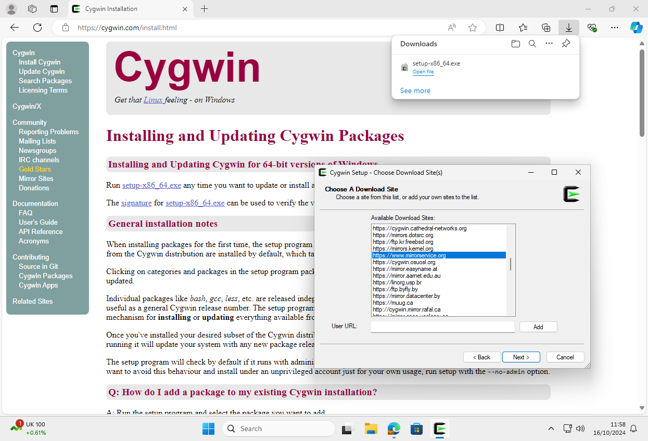

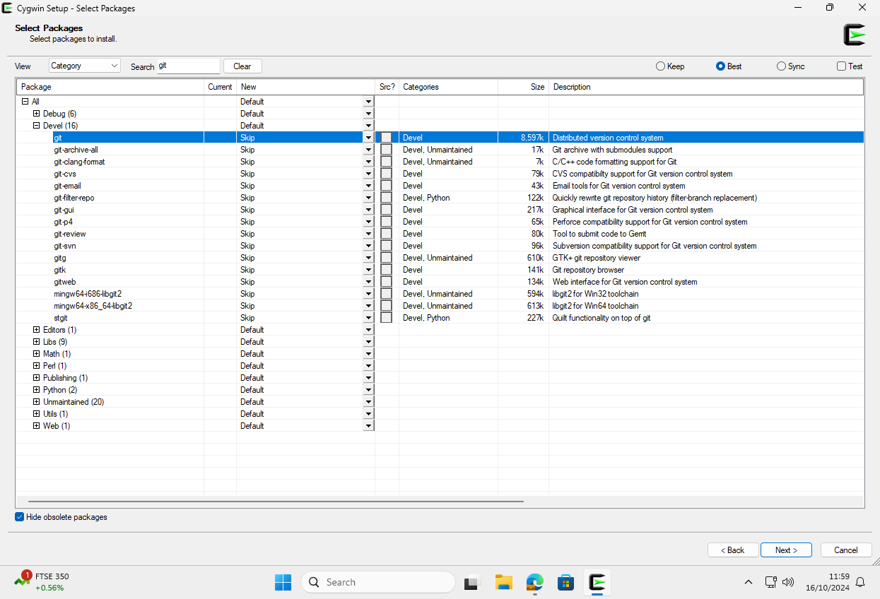

Install Inno Setup from <https://jrsoftware.org/isinfo.php>

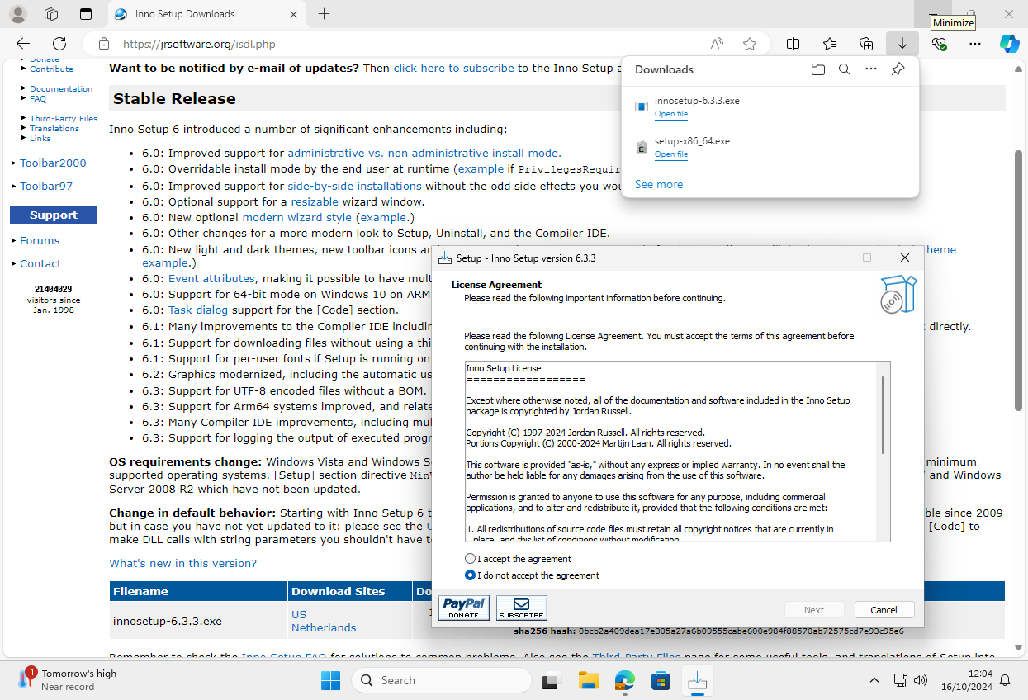

Install Qemu for Windows from <https://qemu.weilnetz.de/w64/>

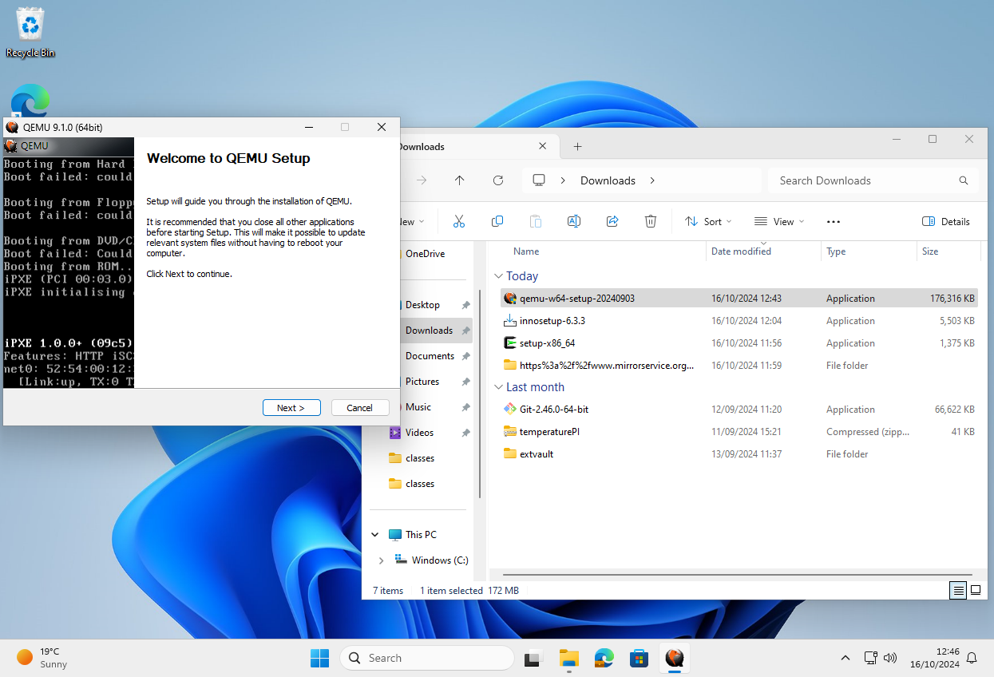

Clone my repository <https://github.com/tjcw/screensavers.git> under cygwin

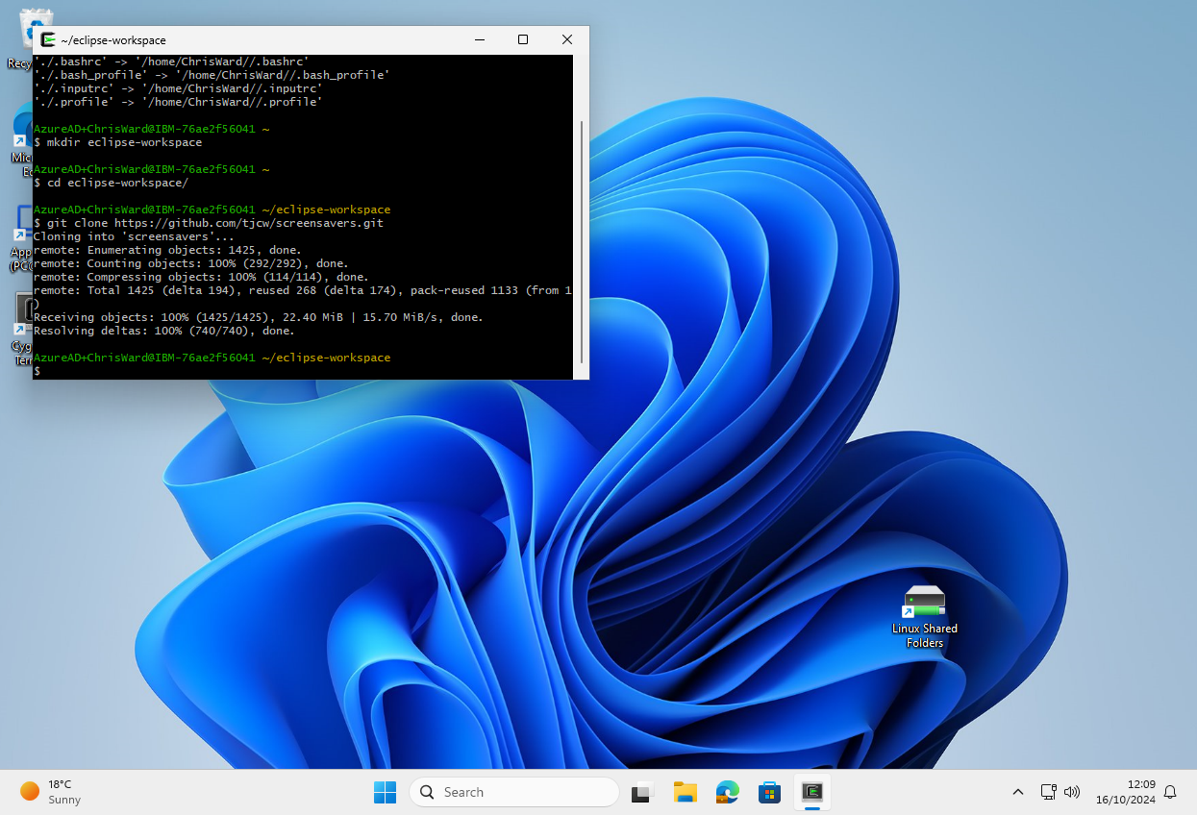

Clone my repository <https://github.com/tjcw/screensavers.git> under WSL2 into directory ~/eclipse-workspace/

$ mkdir ~/eclipse-workspace;cd ~/eclipse-workspace; git clone <https://github.com/tjcw/screensavers.git>

Install ‘live-build’ under WSL2 $ sudo apt install live-build

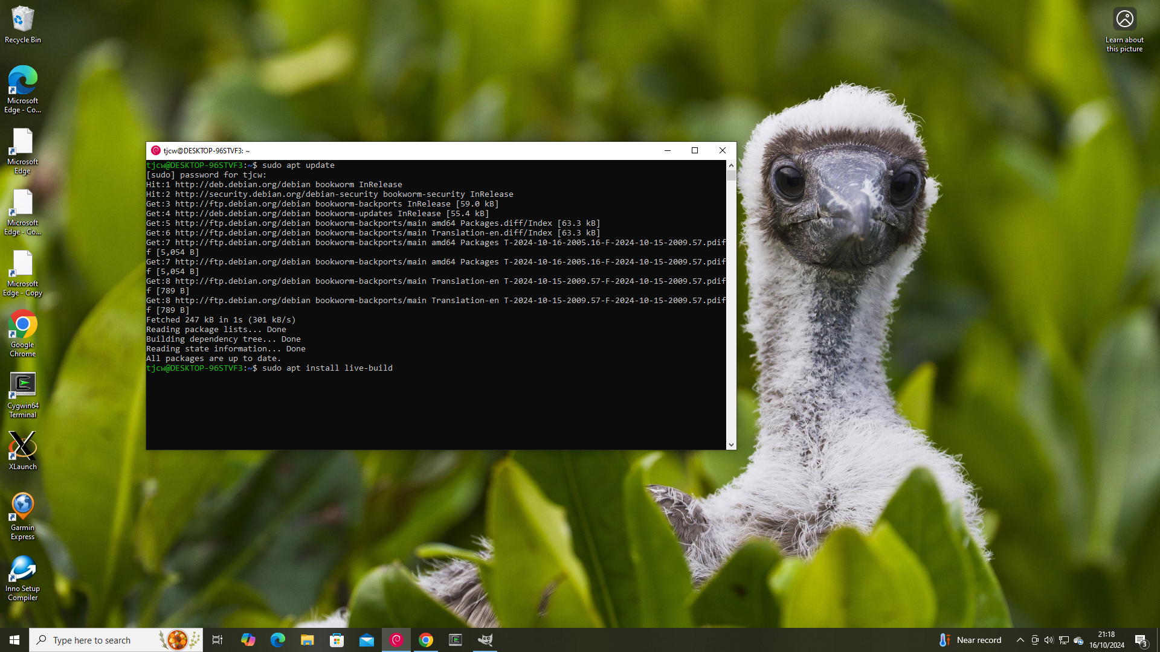

Customise the selection of software to go in the isos (WSL2 commands). There are approximately 65000 packages available in Debian Linux. I chose a few thousand packages for each of 2 screensavers, one with an educational theme and one with an open source games theme.

tjcw@DESKTOP-96STVF3 ~

$ cd eclipse-workspace/

tjcw@DESKTOP-96STVF3 ~/eclipse-workspace

$ cd screensavers/

tjcw@DESKTOP-96STVF3 ~/eclipse-workspace/screensavers

$ cd packaging/

tjcw@DESKTOP-96STVF3 ~/eclipse-workspace/screensavers/packaging

$ mkdir qemu

tjcw@DESKTOP-96STVF3 ~/eclipse-workspace/screensavers/packaging

$ cp -r "/cygdrive/c/Program Files/qemu/." qemu

tjcw@DESKTOP-96STVF3 ~/eclipse-workspace/screensavers/packaging

$ ./package-qemu-open.sh >fr2-open.iss

tjcw@DESKTOP-96STVF3 ~/eclipse-workspace/screensavers/packaging

$

tjcw@DESKTOP-96STVF3:~/lb$ vi ~/eclipse-workspace/screensavers/lb-package-lists/freeduc-bookworm.list.chroot

tjcw@DESKTOP-96STVF3:~/lb$ vi ~/eclipse-workspace/screensavers/lb-package-lists/gk-bookworm.list.chroot

Edit the svg files that you want to use as boot splash screen and wallpaper. This demo uses Inkscape which is cross platform and open source; for present purposes it is easiest to download it from the Windows app store and use the Windows version. The Debian logo is in the screensavers\svgs directory.

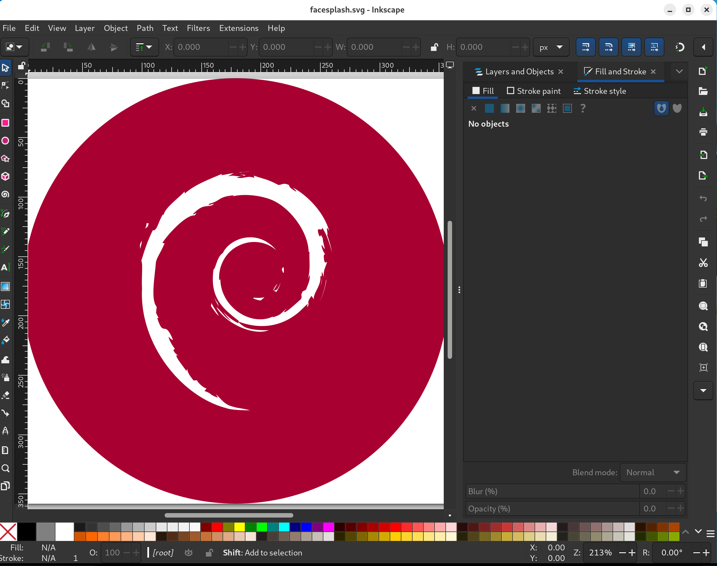

Copy in the SVG files to be used as boot splash screen and wallpaper

tjcw@DESKTOP-96STVF3:~/eclipse-workspace/screensavers$ cp facesplash.svg svgs/facesplash.svg

tjcw@DESKTOP-96STVF3:~/eclipse-workspace/screensavers$ cp wallpaper.svg content/common-files/home/user/face

Run ‘build-both’ under WSL2 to generate the isos

tjcw@DESKTOP-96STVF3:~/lb$ sudo ~/eclipse-workspace/screensavers/bin/build-both

Set up the install script for Inno Setup (Cygwin commands)

Run Inno Setup to create the installers

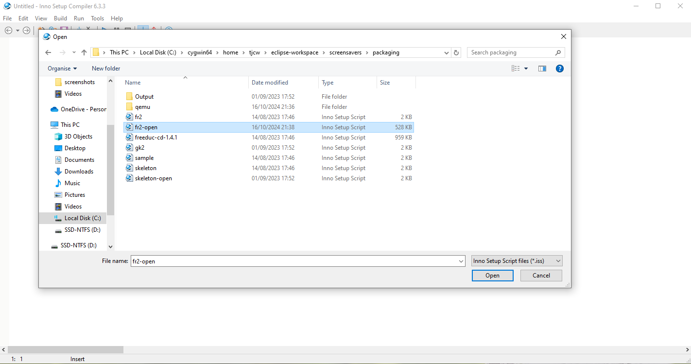

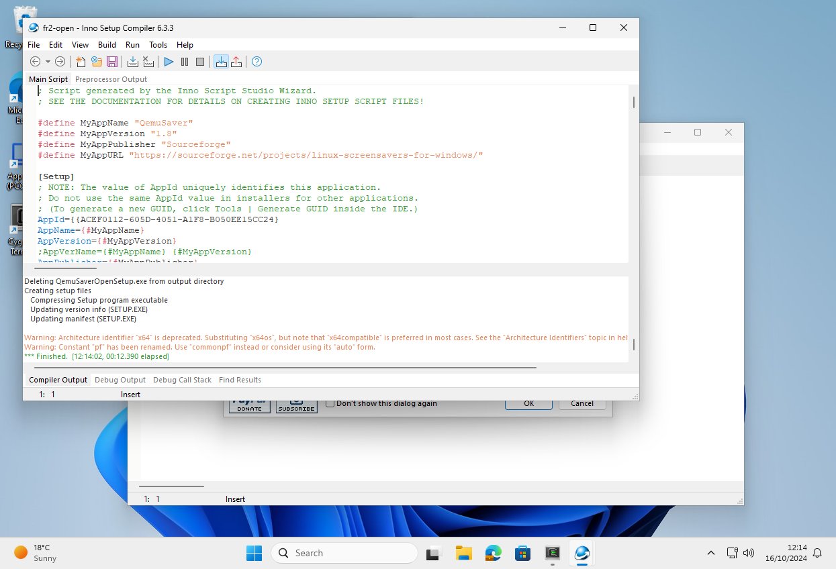

After opening ‘fr2.iss’, choose ‘Build/Compile’.

Transfer the installers and ‘Qemu for Windows’ to WSL2

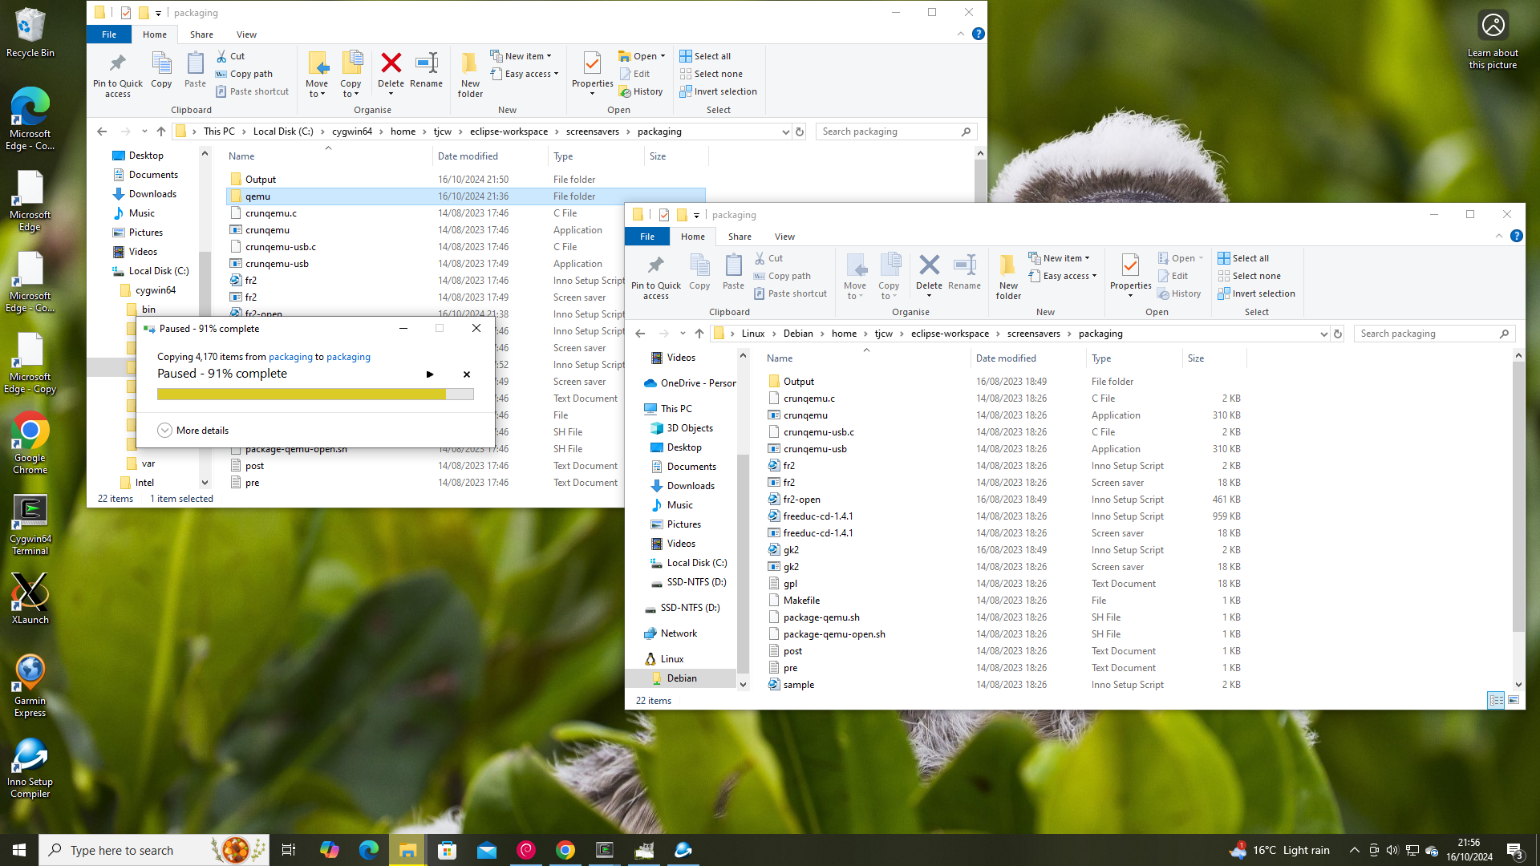

tjcw@DESKTOP-96STVF3:~/assembly/QemuSaverOpen/unzip$ zip -r ../QemuSaverOpen.zip .

tjcw@DESKTOP-96STVF3:~/assembly/GamesKnoppix2/unzip$ zip -r ../GamesKnoppix2.zip .

tjcw@DESKTOP-96STVF3:~/eclipse-workspace/screensavers/bin$ cat setup_assembly

#!/bin/bash -x

mkdir -p ~/assembly/QemuSaverOpen/unzip/extras ~/assembly/GamesKnoppix2/unzip/extras

mv ~/eclipse-workspace/screensavers/packaging/qemu ~/assembly/QemuSaverOpen/unzip/

cp ~/eclipse-workspace/screensavers/packaging/Output/QemuSaverOpenSetup.exe ~/assembly/QemuSaverOpen/unzip/

cp ~/eclipse-workspace/screensavers/packaging/fr2.scr ~/assembly/QemuSaverOpen/unzip/extras/

ln ~/lb/isos/freeduc-bookworm.iso ~/assembly/QemuSaverOpen/unzip/extras/fr2.iso

cp ~/eclipse-workspace/screensavers/packaging/Output/GamesKnoppix2Setup.exe ~/assembly/GamesKnoppix2/unzip/

cp ~/eclipse-workspace/screensavers/packaging/gk2.scr ~/assembly/GamesKnoppix2/unzip/extras/

ln ~/lb/isos/gk-bookworm.iso ~/assembly/GamesKnoppix2/unzip/extras/gk2.iso

tjcw@DESKTOP-96STVF3:~/eclipse-workspace/screensavers/bin$

Set up the unzipped files by running “setup_assembly”

Zip up the ISOs, the installers, and ‘QEMU for Windows’

Transfer the zip files from WSL2 to Windows

Test

Extract each zip file and run the installer exes. Sometimes the installers are detected as malware. They aren't malware, so if necessary add the QemuSaverOpen and GamesKnoppix2 directories to the exclusion list.

Go to screensaver settings and select fr2 or gk2.

Source code

Optionally, run ‘~/eclipse-workspace/bin/fetch_source’ to fetch the source code for all components. You will need the source code if you propose to distribute the screensavers, as recipients may ask you for it. ‘fetch-source’ will download more than 100 GB of data, which may stress the available internet connection.

#!/bin/bash

# Fetch the qemu source

git clone https://repo.or.cz/qemu/ar7.git

# Fetch the inno setup source

git clone https://github.com/jrsoftware/issrc.git

# Fetch the rufus source

git clone https://github.com/pbatard/rufus.git

# Fetch the Debian source

iso_dir=http://cdimage.debian.org/debian-cd/current/source/iso-dvd

wget ${iso_dir}/SHA512SUMS

while read sha512 name

do

wget ${iso_dir}/${name}

done <SHA512SUMS

# Check the checksums

sha512sum -c SHA512SUMS#!/bin/bash

# Fetch the qemu source

git clone https://repo.or.cz/qemu/ar7.git

# Fetch the inno setup source

git clone https://github.com/jrsoftware/issrc.git

# Fetch the rufus source

git clone https://github.com/pbatard/rufus.git

# Fetch the Debian source

iso_dir=http://cdimage.debian.org/debian-cd/current/source/iso-dvd

wget ${iso_dir}/SHA512SUMS

while read sha512 name

do

wget ${iso_dir}/${name}

done <SHA512SUMS

# Check the checksums

sha512sum -c SHA512SUMS

Bibliography

<https://www.researchgate.net/publication/272094609_Linux_screensaver_for_Windows> First publication about running Linux as a Windows screensaver

<https://www.linux.com/news/linux-as-a-screensaver-for-windows-the-gift-of-open-source-games-and-sboms-for-the-holidays/> Updated publication about running Linux as a Windows screensaver

<https://sourceforge.net/projects/linux-screensavers-for-windows/files/release1/> Location on SourceForge where the screensavers in the above article are avaiable for download